Приветствую вас, уважаемые студенты!

- Убедительно прошу Леру и Нахиду прислать мне на почту citrin86@gmail.com выполненные задания за февраль и март. Мой номер телефона 8 958 156 11 20.

Ваш преподаватель
Нина Витальевна

FASHION. CLOTHES

II.Искусство перевода
Переведите тексты и выполните задания Перевод после каждого абзаца. Пользуйтесь любым переводчиком, но правьте перевод!
What is Fashion?
Fashion is something we deal with every day. Even people who say they do not care what they wear choose clothes every morning that say a lot about them and how they feel that day.
One certain thing in the fashion world is change. We are constantly being bombarded with new fashion ideas from music, videos, books, and television. Movies also have a big impact on what people wear. Ray-Ban sold more sunglasses after the movie Men In Black. Sometimes a trend is worldwide. Back in the 1950s, teenagers everywhere dressed like Elvis Presley.

Who dictates fashion?
Musicians and other cultural icons have always influenced what we are wearing, but so have political figures and royalty. Newspapers and magazines report on what Hillary Clinton wears. The recent death of Diana, the Princess of Wales, was a severe blow to the high fashion world, where her clothes were daily news.
Even folks in the 1700s pored over fashion magazines to see the latest styles. Women and dressmakers outside the French court relied on sketches to see what was going on. The famous French King Louis XIV said that fashion is a mirror. Louis himself was renowned for his style, which tended towards extravagant laces and velvets.

Clothes separate people into groups.
Fashion is revealing. Clothes reveal what groups people are in. In high school, groups have names: "Goths, skaters, preps, herbs." Styles show who you are, but they also create stereotypes and distance between groups. For instance, a businessman might look at a boy with green hair and multiple piercings as a freak and outsider. However, to another person, the boy is a strict conformist. He dresses a certain way to deliver the message of rebellion and separation, but within that group, the look is uniform. Acceptance or rejection of a style is a reaction to the society we live in.
Fashion is a language, which tells a story about the person who wears it. "Clothes create a wordless means of communication that we all understand," according to Katharine E. Hamnett, a top British fashion designer. Hamnett became popular when several rock bands wore her t-shirts with large messages like «Choose Life».
There are many reasons we wear what we wear.
Protection from cold, rain and snow: mountain climbers wear high-tech outerwear to avoid frostbite and over-exposure. Physical attraction: many styles are worn to inspire "chemistry." Emotions: we dress "up" when we are happy and "down" when we are upset.
Religious expression: Orthodox Jewish men wear long black suits and Islamic women cover every part of their body except their eyes. Identification and tradition: judges wear robes, people in the military wear uniforms, brides wear long white dresses. Fashion is big business. More people are involved in the buying, selling and production of clothing than any other business in the world. Every day, millions of workers design, sew, glue, dye, and transport clothing to stores. Ads on buses, billboards and magazines give us ideas about what to wear, consciously, or subconsciously. Clothing can be used as a political weapon. In nineteenth century England, laws prohibited people from wearing clothes produced in France. During the twentieth century communist revolutions, uniforms were used to abolish class and race distinctions.
Fashion is an endless popularity contest.
High fashion is the style of a small group of men and women with a certain taste and authority in the fashion world. People of wealth and position, buyers for major department stores, editors and writers for fashion magazines are all part of Haute Couture ("High Fashion" in French). Some of these expensive and often artistic fashions may triumph and become the fashion for the larger majority. Most stay on the runway.
Popular fashions are close to impossible to trace. No one can tell how the short skirts and boots worn by teenagers in England in 1960 made it to the runways of Paris, or how blue jeans became so popular in the U.S., or how hip-hop made it from the streets of the Bronx to the Haute Couture fashion shows of London and Milan.
It's easy to see what's popular by watching sit-coms on television: the bare mid-riffs and athletic clothes of 90210, the baggy pants of The Fresh Prince of Bel-Air. But the direction of fashion relies on "plugged-in" individuals to react to events, and trends in music, art and books.
"In the perspective of costume history, it is plain that the dress of any given period is exactly suited to the actual climate of the time." according to James Laver, a noted English costume historian. How did bell-bottom jeans fade into the designer jeans and boots look of the 1980s into the baggy look of the 1990s? Nobody really knows.
Once identified, fashions begin to change.
Fashion
Every day, people wake up and wonder what they are going to wear. The suit and tie? The fast-food smock? Do we ever really think about why we go to all this trouble, or are we clueless? Why does fashion exist?
People use fashion to present themselves to the public eye. What we wear is an image of what we want the world to see.
Fashion exists to provide information about ourselves, who we think we are and who we aspire to be. It defines our age, our sex, our occupation and often, our ethnicity. A man walks down the street in a business suit -- and we gather information about him. A young girl wears a tank top and short pink skirt - and we form an impression of her.
Fashion has evolved over the centuries. In cultures that wear few clothes, body paint is used as a substitute. In some cultures, the powerful decide what everyone wears. They use laws to mark off different segments of society from each other.
Today we tend to dress based on the way clothes appeal to our personal taste. If we like it, we like it. If we don't, we don't. We chose our style to express our personality. It's nice to be cool and to dress with the times. But let's be serious, what's cool now is probably going to look silly in a few years.
- Кто на фотографии? Найдите информацию в текстах.
- 1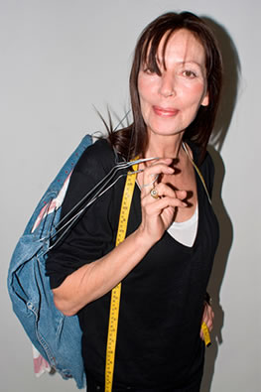 2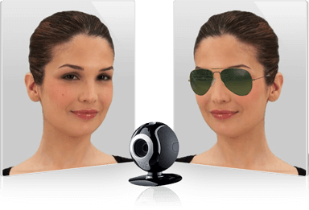
3 4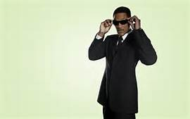
5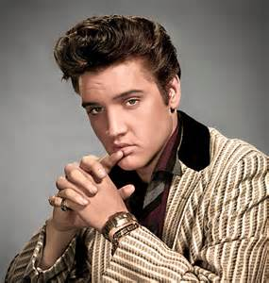 6 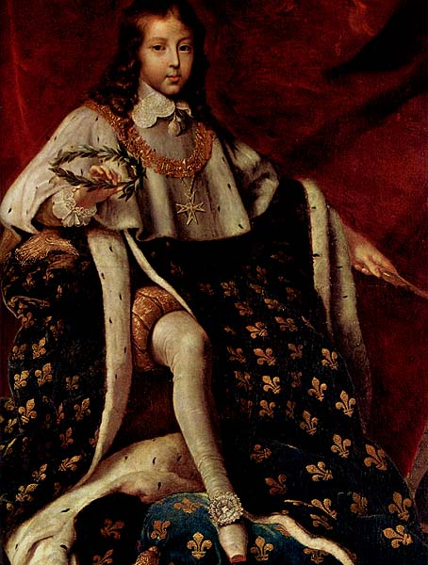
7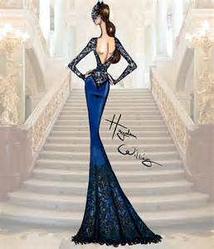 8
- 10
2.Зайдите на ресурс, выберите и переведите статью ВЫПОЛНИТЬ!
https://www.fashionmuseum.co.uk/

